Thanks for downloading this business plan template from Bplans.com!
(Click here for PDF version)
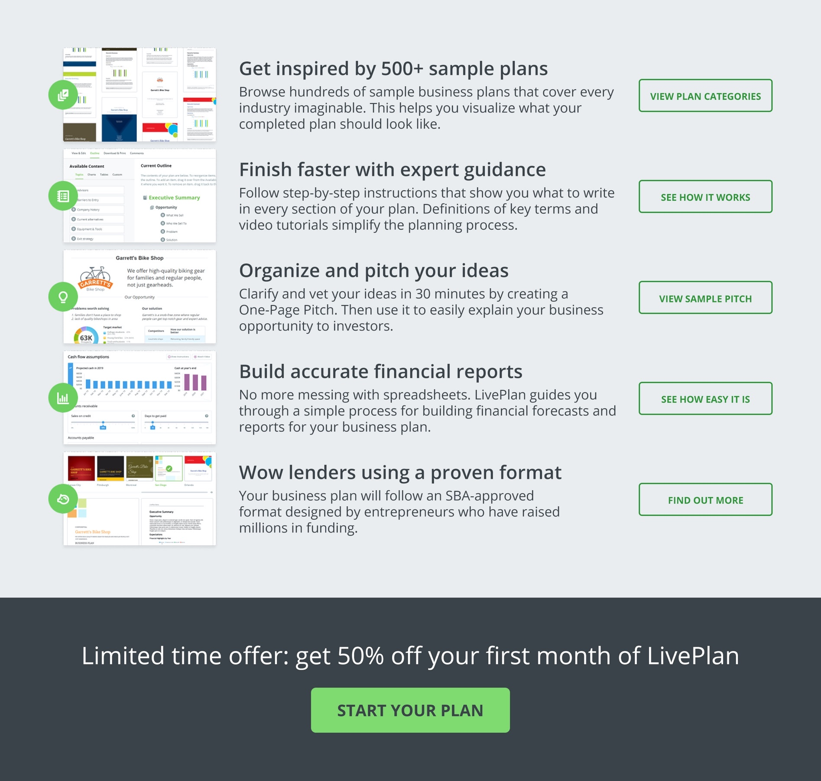
This template is a simplified business plan outline. It’s a good way to get started, but as you know, you can’t just type in your details, print it, and turn it in to the bank. Every business is unique, and your business plan should reflect that.
LivePlan can help. With LivePlan, you can easily create a unique business plan, with all the financial tables and graphs to go with it. You’ll also be able to:

CONFIDENTIAL

[Your company name here]

Your tagline

Business Plan

Prepared [date]

Contact Information
Jane Smith jane@yourcompany.com 111-222-3333
www.yourcompany.com 1234 Main St.
Anywhere, OR 12345, USA

Table of Contents

Executive Summary 1
Opportunity 1
Expectations 1
Opportunity 3
Problem & Solution 3
Target Market 3
Competition 3
Execution 4
Marketing & Sales 4
Operations 4
Milestones & Metrics 5
Company 6
Overview 6
Team 6
Financial Plan 7
Forecast 7
Financing 9
Statements 10
Appendix 13
Profit and Loss Statement 13
Balance Sheet 15
Cash Flow Statement 17

Executive Summary

Opportunity

Problem Summary
INSTRUCTIONS: Describe very briefly why your business needs to exist. What problem do you solve for your customers?

Solution Summary
INSTRUCTIONS: Briefly summarize what your company does. The executive summary should be very short and you can go into more detail later in the plan.

Market
INSTRUCTIONS: Describe your target customer or market segments. Again, keep things very brief in the executive summary and add more detail later in the plan.

Competition
INSTRUCTIONS: Summarize your key competition. Who will your customers also consider?

Why Us?
INSTRUCTIONS: Write a brief overview of you and your team. Why are you the right people to build this business?

Expectations

Forecast
INSTRUCTIONS: Write a brief overview of your financial targets. How much do you plan to sell in the next year? What are your long-term sales goals?

Financial Highlights by Year

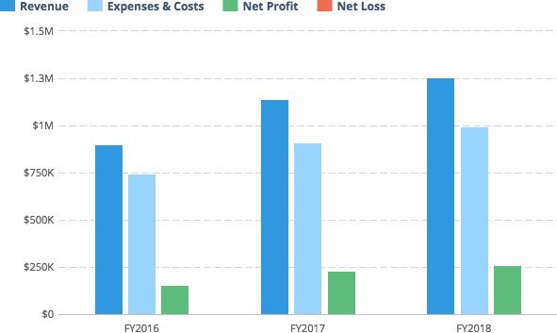

INSTRUCTIONS: Insert a chart of your key financial metrics here. Tools like LivePlan will do this for you automatically.

Financing Needed
INSTRUCTIONS: If you are writing a business plan to raise money for your business, include a brief summary of what you are looking for. If you aren’t raising money or getting a loan, you can delete this section.

Opportunity

Problem & Solution

Problem Worth Solving
INSTRUCTIONS: Write a little more detail than you provided in the Executive Summary about the problem you are solving. What do your customers need? Do they need a better product, a cheaper product, or just a store in a better location? Describe why customers will want to buy from you.

Our Solution

INSTRUCTIONS: Provide additional detail, beyond what you wrote in the Executive Summary, about your product or service. What is unique and special about your company that’s going to set it apart from the competition?

Target Market

Market Size & Segments
INSTRUCTIONS: Describe your key customers – who they are and what their key attributes are. If your company is targeting multiple customer groups (also called ‘segments’), describe each group here. If you can, include details about how many people are in each segment and how large the total market is.

Competition

Current Alternatives
INSTRUCTIONS: Describe your current competition. What products and services are people using instead of yours?

Our Advantages
INSTRUCTIONS: Explain why your product or service is better than the others. Also, be sure to describe any competitive advantages you may have, such as a patent or other unique component to your business.

Execution

Marketing & Sales

Marketing Plan
INSTRUCTIONS: Explain how you plan on getting the word out about your product to your target market(s). Will you use advertising? Perhaps you are developing a content marketing strategy. Whatever your marketing plans may be, describe them here.

Sales Plan

INSTRUCTIONS: If your company relies on sales people to close sales deals, you need a sales plan. Your sales plan should explain how you convert people who express interest in your product or service into paying customers. If you are opening a food truck, this section is less important and you can consider removing it. However, if you are starting a sales-heavy business like enterprise software or a car dealership, then you need to document how you will nurture leads and close deals.

Operations

Locations & Facilities
INSTRUCTIONS: Describe your company’s physical locations. This might be your office, store locations, manufacturing plants, storage facilities — whatever is relevant to your business. How much space do you have available, and how well will it meet your current and future needs?

Technology
INSTRUCTIONS: Describe any important software, hardware, or other information technology that you use now or plan to use later to operate your business. That might include a point-of-sale system to take payments, an e-commerce engine for your website, a CRM solution for managing your pipeline, marketing tools for generating leads, and so on.

Equipment & Tools
INSTRUCTIONS: List any specialty equipment that you have or plan to acquire to do your work. This is an important component of the business plan for many industrial companies.

Milestones & Metrics

Milestones

INSTRUCTIONS: List your key milestones and the dates that you hope to accomplish them by. If you’ve already accomplished key goals for your business, list them here as evidence that your business is getting traction – in other words, it’s getting positive attention from potential customers.

Key Metrics
INSTRUCTIONS: Explain which performance metrics are most important for understanding how your business is doing. What does success mean for you, and how will you know it when you see it?

Company

Overview

INSTRUCTIONS: Use this area to specify who owns your company. If there are multiple owners, describe each of them and how much of an ownership stake they have. Also, identify your company’s legal structure. Is it a sole proprietorship — that is, just you working for yourself? Or a partnership, such as a limited-liability corporation (LLC) or partnership (LLP), where the profits pass through to the partners involved? Or a nonprofit organization? Or a proper S- or C-type corporation with its own tax obligations and the rest?

Team

Management Team
INSTRUCTIONS: List the members of the management team, including yourself. Describe each person’s skills and experience and what they will be doing for the company. It’s OK if you don’t have everyone for a complete management team yet. In that case, make sure to identify gaps in your team that you intend to fill over time.

Advisors
INSTRUCTIONS: Describe any mentors, investors, former professors, industry or subject-matter experts, knowledgeable friends or family members, small-business counselors, or others who can help you as a business owner.

Financial Plan

Forecast

Key Assumptions
INSTRUCTIONS: Describe how you came up with the values in your financial forecast. Did you project your revenue based on past results, market research, your best guess at how many people who visit your store and what percentage of them might buy, or some other method? What kind of growth are you assuming? What are your key hires and notable expenses? What level of profit do you expect to generate?

Revenue by Month

INSTRUCTIONS: Include a chart that shows your projected revenue. A tool like LivePlan can help you create a chart like this and automatically include it in your business plan.

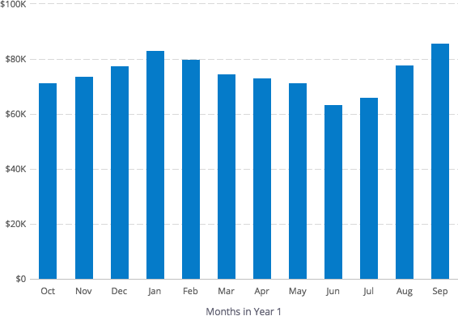

Expenses by Month
INSTRUCTIONS: Include a chart that shows your projected expenses. A tool like LivePlan can help you create a chart like this and automatically include it in your business plan.

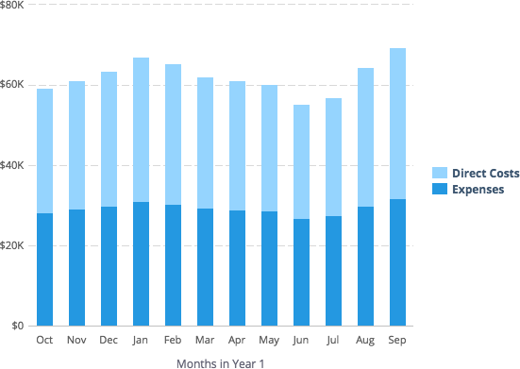

Net Profit (or Loss) by Year
INSTRUCTIONS: Include a chart that shows your projected expenses. A tool like LivePlan can help you create a chart like this and automatically include it in your business plan.

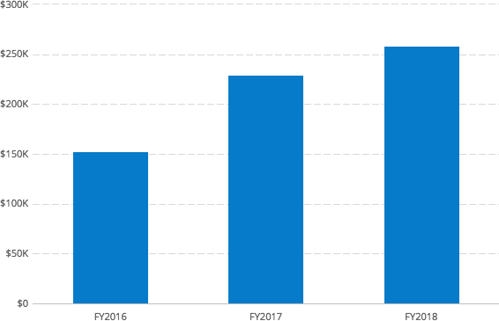

Financing

Use of Funds
INSTRUCTIONS: If your forecast includes loans, investments, or other financing, use this space to explain what you plan do with that money.

Sources of Funds
INSTRUCTIONS: Describe your financing plans. Are you investing your own money in the business? Do you have a credit card or line of credit? What other types of funds — personal or business loans, equity investments from others, etc. — do you expect to receive and when? If you do not have the full detail of future financing worked out yet, that is understandable. Just explain what you do know and when you expect to sort out the details.

Statements

Projected Profit & Loss
INSTRUCTIONS: Provide a summary of your financial forecast here. You can certainly do this by yourself, but tools like LivePlan make it much easier.

FY2018 | FY2019 | FY2020
Revenue
Direct Costs
Gross Margin
Gross Margin %
Operating Expenses
Salary
Employee Related Expenses
Total Operating Expenses
Operating Income
Interest Incurred
Depreciation and Amortization
Income Taxes
Total Expenses
Net Profit
Net Profit / Sales

Projected Balance Sheet
INSTRUCTIONS: Include your balance sheet here.
FY2018 | FY2019 | FY2020
Cash
Accounts Receivable
Inventory
Other Current Assets
Total Current Assets
Long-Term Assets
Accumulated Depreciation
Total Long-Term Assets
Total Assets
Accounts Payable
Income Taxes Payable
Sales Taxes Payable
Short-Term Debt
Prepaid Revenue
Total Current Liabilities
Long-Term Debt
Total Liabilities
Paid-in Capital
Retained Earnings
Earnings
Total Owner's Equity
Total Liabilities & Equity

Projected Cash Flow Statement
INSTRUCTIONS: Include your cash flow statement here.
FY2018 | FY2019 | FY2020
Net Cash Flow from Operations
Net Profit
Depreciation and Amortization
Change in Accounts Receivable
Change in Inventory
Change in Accounts Payable
Change in Income Tax Payable
Change in Sales Tax Payable
Change in Prepaid Revenue
Net Cash Flow from Operations
Investing & Financing
Assets Purchased or Sold
Investments Received
Change in Long-Term Debt
Change in Short-Term Debt
Dividends & Distributions
Net Cash Flow from Investing & Financing
Cash at Beginning of Period
Net Change in Cash
Cash at End of Period

Appendix

Profit and Loss Statement (With Monthly Detail)

FY2018 | Mar '17 | Apr '17 | May '17 | Jun '17 | Jul '17 | Aug '17 | Sep '17 | Oct '17 | Nov '17 | Dec '17 | Jan '18 | Feb '18
Revenue
Direct Costs
Gross Margin
Gross Margin %
Operating Expenses
Salary
Employee Related Expenses
Total Operating Expenses
Operating Income
Interest Incurred
Depreciation and Amortization
Income Taxes
Total Expenses
Net Profit
Net Profit / Sales

Profit and Loss Statement (Annual Detail)

FY2018 | FY2019 | FY2020
Revenue
Direct Costs
Gross Margin
Gross Margin %
Operating Expenses
Salary
Employee Related Expenses
Total Operating Expenses
Operating Income
Interest Incurred
Depreciation and Amortization
Income Taxes
Total Expenses
Net Profit
Net Profit / Sales

Balance Sheet (With Monthly Detail)

FY2018 Mar
'17

Apr '17 May '17 Jun '17 Jul '17 Aug '17 Sep '17 Oct '17 Nov '17 Dec '17 Jan '18 Feb '18

Cash

Accounts Receivable Inventory
Other Current Assets

Total Current Assets

Long-Term Assets Accumulated Depreciation Total Long-Term Assets
Total Assets

Accounts Payable Income Taxes Payable Sales Taxes Payable Short-Term Debt Prepaid Revenue
Total Current Liabilities

Long-Term Debt

Total Liabilities

Paid-in Capital Retained Earnings Earnings
Total Owner's Equity

Total Liabilities & Equity

Balance Sheet (Annual Detail)

FY2018 | FY2019 | FY2020
Cash
Accounts Receivable
Inventory
Other Current Assets
Total Current Assets
Long-Term Assets
Accumulated Depreciation
Total Long-Term Assets
Total Assets
Accounts Payable
Income Taxes Payable
Sales Taxes Payable
Short-Term Debt
Prepaid Revenue
Total Current Liabilities
Long-Term Debt
Total Liabilities
Paid-in Capital
Retained Earnings
Earnings
Total Owner's Equity
Total Liabilities & Equity

Cash Flow Statement (With Monthly Detail)

FY2018 Mar
'17

Apr '17 May '17 Jun '17 Jul '17 Aug '17 Sep '17 Oct '17 Nov '17 Dec '17 Jan '18 Feb '18

Net Cash Flow from Operations

Net Profit

Depreciation and Amortization

Change in Accounts Receivable

Change in Inventory

Change in Accounts Payable

Change in Income Tax Payable

Change in Sales Tax Payable Change in Prepaid Revenue
Net Cash Flow from Operations
Investing & Financing

Assets Purchased or Sold Investments Received Change in Long-Term Debt Change in Short-Term Debt Dividends & Distributions
Net Cash Flow from Investing & Financing
Cash at Beginning of Period

Net Change in Cash

Cash at End of Period

Cash Flow Statement (Annual Detail)

FY2018 | FY2019 | FY2020
Net Cash Flow from Operations
Net Profit
Depreciation and Amortization
Change in Accounts Receivable
Change in Inventory
Change in Accounts Payable
Change in Income Tax Payable
Change in Sales Tax Payable
Change in Prepaid Revenue
Net Cash Flow from Operations
Investing & Financing
Assets Purchased or Sold
Investments Received
Change in Long-Term Debt
Change in Short-Term Debt
Dividends & Distributions
Net Cash Flow from Investing & Financing
Cash at Beginning of Period
Net Change in Cash
Cash at End of Period

